What is a sound approach to leveraging social media tools and platforms?

- Strategy Planning Summary
  - Budget
  - Lead time for each campaign
  - Length of campaign
  - What does success look like? Measurable?
  - Distribution of the content? What channels?
  - Will ads be used?
  - What type of content will be posted?
  - Frequency of postings?
  - Increase Branded traffic
  - Social media leads
  - SEO and ranked search

- Social Media Planning
  - Create a list of influencers – know your audience & industry – measure follower count and engagement
    - Luxury/high end clothing – follow and engage with luxury fashion influencers
    - Give credit to authors/contributors when posting/sharing
    - Comment, share and like often – gain influence
    - Convince target influencers to help reach your goals, create power users who you influence
    - Create brand ambassadors
    - Build, Engage – follow, retweet and create an ongoing conversations/relationship
  - Network with relevant social sites, media channels
  - Partner with the community and charities
  - Company bio available – company objectives, contact info, mission statement, hours, motto, slogan
  - Share – product launches, store openings, sales/promotions, giveaways, contest

- Plan Execution
  - Quality (custom banners/professionalism) over quantity, don’t over invest for quantity
    - Use photos, infographics when posting – visual stimulation, limit distractions
  - Customize content for that social channel, repurpose content(same msg in different formats/wording)
  - Start small, based on strategy – go with the basic platforms – Facebook, linkedin, youtube, twitter, blog
    - Market to your audience, slowly expand to other appropriate platforms – Instagram, Periscope, snapchat, podcast, Pinterest, location based platforms(yelp, foursquare, google maps, level up)..etc.
  - Avoid aggressive marketing
  - Don’t always promote, create & provide value
  - Build trust - build loyalty - (influencers),
  - Move offline - Real life how to guides & workshops
  - Professionalism and tasteful content, authentic, Don’t be boring
  - Commit – long term, stick with the plan, get out what you put in
  - Utilize Social Management Tools
    - Automation
    - Cross channel sharing

- Review and Assessment
  - Measure results – Google Analytics, Moz Open Site Explorer, internal KPIs, internal sales
  - Measure the metrics – look for correlations, shared product gets likes = higher product sales
  - Revise the strategy – review KPIs, try A/B testing
  - Know your content and what’s working
  - Track competitors
  - Increase on ROI over time as online presence grows and invest in micro-targeting
  - EMV metric – Earned Media Value
  - CPE – Cost per Engagement
  - Total Social Reach

- Recap/Closing
  - Target Audience / Engagement
  - Lead Generation
  - Sales
  - Customer retention
  - Customer service
  - Brand awareness / advertising

References:
https://www.researchgate.net/publication/227413605_Social_Media_Get_Serious_Understanding_the_Functional_Building_Blocks_of_Social_Media PDF Doc / Case

https://www.entrepreneur.com/article/284918

http://www.socialmediatoday.com/social-business/7-step-guide-leveraging-social-media-influencer-marketing

https://buildfire.com/social-media-tools-2/

http://seattlebusinessmag.com/business-corners/7-key-steps-leveraging-social-media-marketing-drive-real-results-0

https://www.inc.com/aj-agrawal/6-ways-to-leverage-social-media-for-your-business.html

https://www.researchgate.net/publication/229402674_We're_all_connected_The_power_of_the_social_media_ecosystem PDF Doc / Case

http://www.curata.com/blog/social-media-marketing-content-marketing/

http://www.wordstream.com/social-media-marketing

https://www.forbes.com/sites/jaysondemers/2017/04/05/7-reasons-social-media-marketing-is-still-underrated/

https://www.spinutech.com/blog/digital-marketing/how-businesses-can-leverage-an-influencer-strategy-on-social-media/

https://www.rhythmone.com/assets/insights/1R_2016_Influencer_Marketing_Guide.pdf PDF Doc / Case – Good doc

https://www.slideshare.net/dedmond29/ecommerce-smart-logistics-building-the-right-digital-foundation - Great slides/data

“Mobile Ad Spend to Top $100 Billion Worldwide in 2016, 51% of Digital Market,” eMarketer, April 2, 2015. http://www.emarketer.com/Article/Mobile-Ad-Spend-Top-100-Billion-Worldwide-2016-51-of-Digital-Market/1012299

“Worldwide, More Than Half of Google’s Searches Happen on Mobile,” Search Engine Land, October 8, 2015. http://searchengineland.com/half-of-google-search-is-mobile-232994

StatCounter GlobalStats, Platform Comparison, December2008 to May 2016. http://gs.statcounter.com/#all-comparison-ww-monthly-200812-201605

“Facebook’s Ad Volume Has Grown for the First Time in Two Years,” Ad Age, January 27, 2016. http://adage.com/article/digital/facebook-q4-2016-earnings/302378

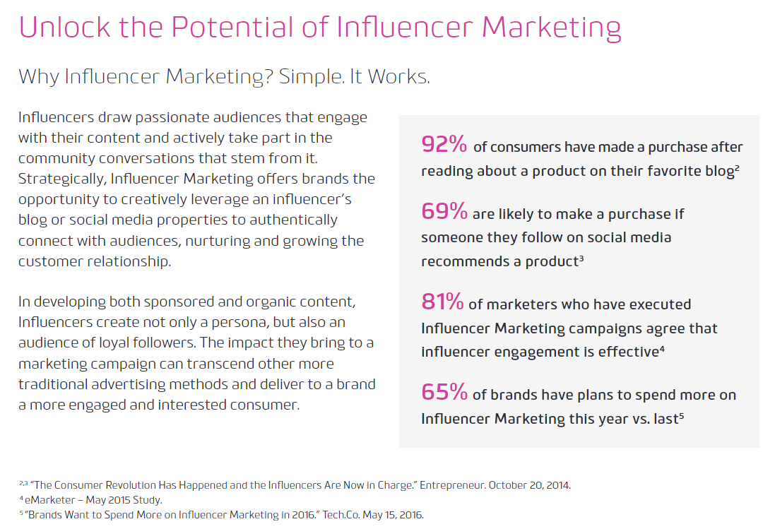

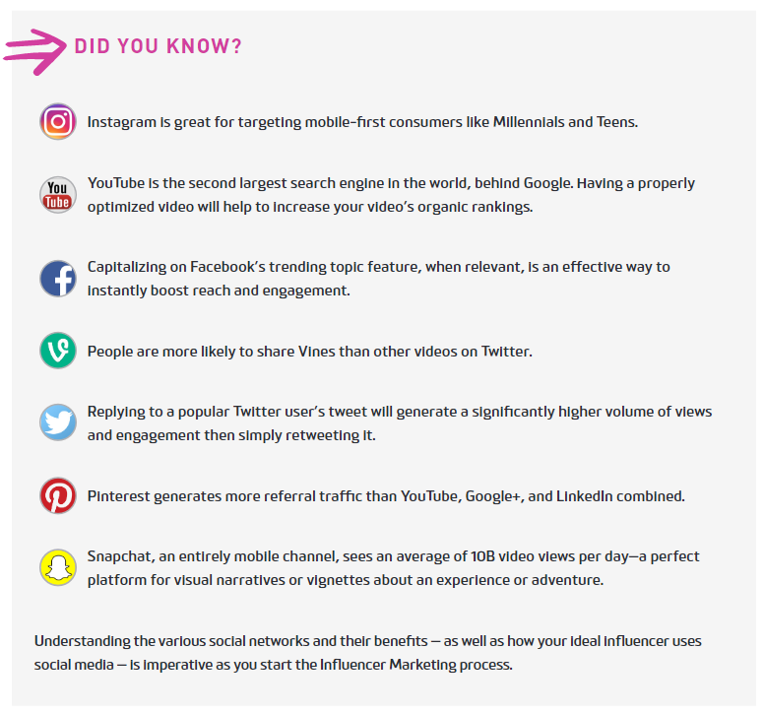

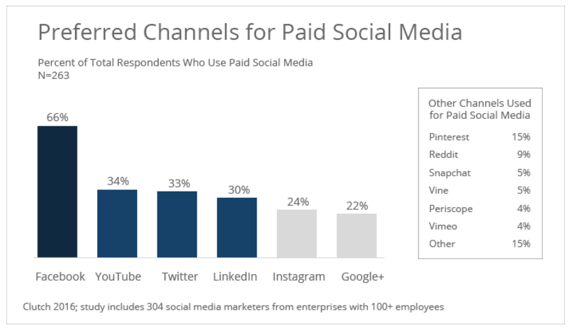

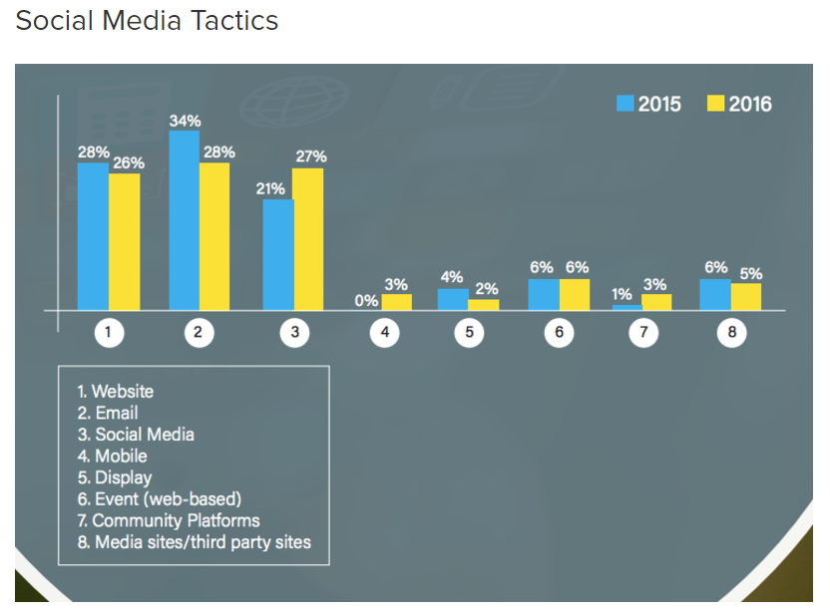

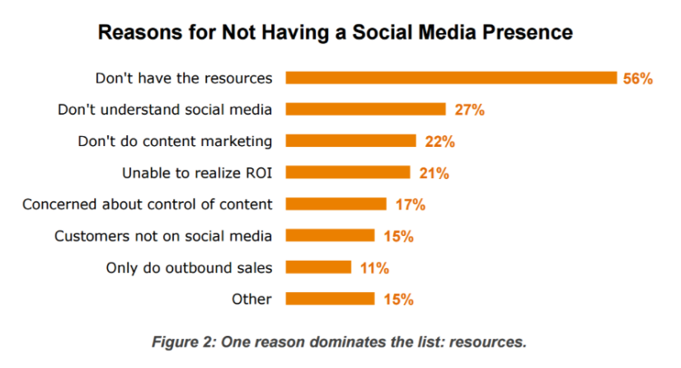

Dark Social
The Dark Side of Mobile Sharing
https://drive.google.com/file/d/0BzcKg0_DslYFOERlOTVaYWhTQm8/view
